ORTHOPAEDIC INSTRUMENTS
Plaster Cutting Instruments
Electric Plaster Cutting Saw with 2 Blades
Intended Use
The electric plaster cutting saw is a powered oscillating instrument used to remove plaster of Paris and fibreglass casts from veterinary patients without skin injury. The oscillating blade cuts rigid cast material efficiently while the non-rotating blade tip is safe for skin contact, enabling rapid, atraumatic cast removal. | 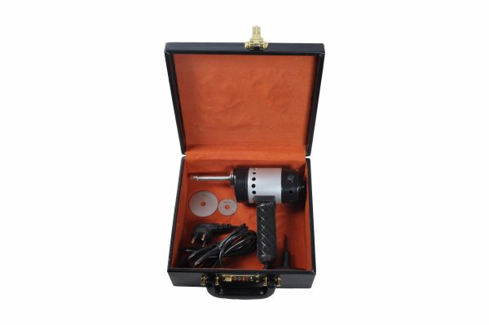
Function
An electric motor drives the blade in a rapid oscillating arc rather than full rotation. This oscillating motion cuts brittle cast material but stops cutting when it contacts the soft, yielding skin beneath the cast — the fundamental safety principle that makes oscillating saws essential for cast removal in small and large animal veterinary practice.
Advantages
Skin-Safe Oscillating Action: The oscillating blade cuts plaster and fibreglass but not skin, providing a large safety margin for cast removal even in areas where the cast wall is thin and the blade is close to the skin surface — critical in small animal cast removal where patient movement increases injury risk.
Dual Blade Set Versatility: Two blades included in the set cover standard plaster (coarser blade) and fibreglass casts (finer blade), allowing effective cutting of both common cast materials with a single instrument without the need for blade changes mid-procedure.
FAQ
Q: Can the electric plaster saw cut fibreglass casts?
A: Yes — the finer blade in the kit is designed for fibreglass; fibreglass is tougher than plaster and requires the sharper, finer-toothed blade for efficient cutting without excessive heat generation.
Q: How is heat generation managed during plaster saw use?
A: Move the saw blade progressively along the cast without dwelling in one location, and allow the blade to cool periodically; excessive dwell time generates heat that causes thermal skin injury even through the cast padding.

ORTHOPAEDIC INSTRUMENTS
Plaster Cutting Instruments
Plaster Bender
Intended Use
The plaster bender is used to spread and bend the cut edges of a plaster cast after the initial longitudinal cuts have been made during cast bivalving or windowing in veterinary patients. It is a critical step in controlled cast removal that protects the skin from laceration by the cut cast edges. | 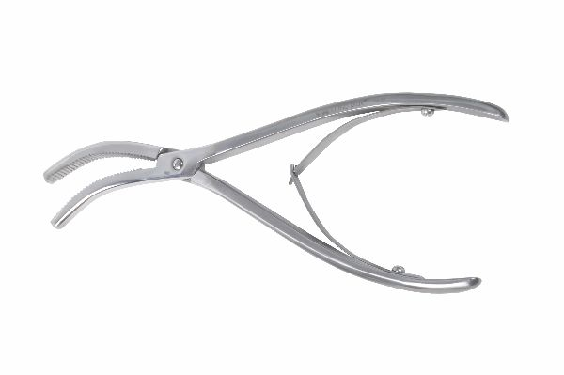
Function
The two broad, blunt-edged jaws are introduced into the cast cuts and levered apart, bending the plaster walls outward. Progressive positioning along the cut length allows the full cast to be bent open evenly, preventing the sudden cracking and sharp edge creation that occurs when the cast is bent from a single point without the bender.
Advantages
Safe Cast Edge Spreading: The bender progressively opens the cast cut without creating the sharp plaster shards that form when casts are cracked apart by hand, reducing the risk of skin laceration from sharp cast edges during cast removal in fractious or moving patients.
Controlled Bivalving: Systematic use of the bender ensures the cast opens evenly along its full length, preventing partial opening where one end opens while the other remains closed and exerts torsional force on the healing limb.
FAQ
Q: Is the plaster bender used after every cast cut?
A: The bender is used after bilateral longitudinal cuts have been made to bivalve the cast; it may also be used for cast windowing where one section is bent outward for wound inspection access.
Q: Can the plaster bender damage the limb if used incorrectly?
A: Excessive force or off-axis levering can transmit leverage to the healing fracture; use steady, controlled force along the cut lines and support the limb distally during bending to prevent lever arm forces reaching the fracture site.

ORTHOPAEDIC INSTRUMENTS
Plaster Cutting Instruments
Plaster Knife
Intended Use
The plaster knife is a heavy-bladed cutting instrument used to score, cut, and trim plaster of Paris cast material during cast application and removal in veterinary patients. Its robust blade handles the thick, abrasive plaster material that would rapidly dull standard surgical blades or tissue scissors. | 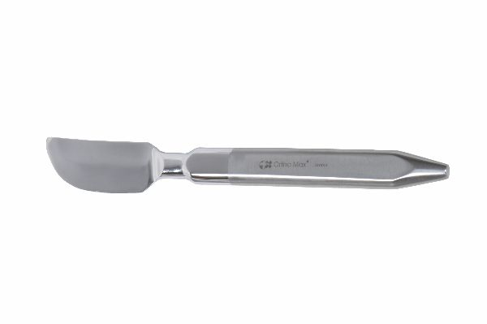
Function
The thick, rigid steel blade is drawn along the cast surface to score or cut through the plaster layer. The blade geometry is optimised for the semi-rigid, abrasive nature of drying or set plaster, maintaining a cutting edge through the extended cutting action needed for longitudinal cast incisions.
Advantages
Plaster-Specific Blade Durability: The reinforced blade maintains a usable cutting edge through extended plaster-cutting work that would instantly dull standard surgical blades, providing reliable cutting performance through the full cast application and trimming procedure without blade replacement.
Controlled Trimming Accuracy: The stiff, rigid blade prevents the flexing that thin blades exhibit in plaster, allowing accurate trimming of cast edges to precise contours that maximise the cast's biomechanical effectiveness while minimising patient discomfort from overly long or rough-edged cast margins.
FAQ
Q: Can a plaster knife be used to cut bandages?
A: The heavy plaster knife can cut through bandage materials but is less precise than bandage scissors; dedicated bandage scissors are preferred for outer bandage layer removal while the plaster knife handles the rigid cast layer.
Q: How is the plaster knife sharpened?
A: A flat whetstone hones the single-bevel blade; plaster's abrasive nature dulls the blade edge rapidly, so regular honing after each few cases maintains effective cutting performance.

ORTHOPAEDIC INSTRUMENTS
Plaster Cutting Instruments
Plaster Saw
Intended Use
The manual plaster saw is a hand-powered serrated saw used to cut through plaster of Paris casts during cast removal in veterinary patients without electrical power. It provides a reliable backup for cast removal when the electric plaster saw is unavailable and for cutting in locations where the powered saw is difficult to manoeuvre. | 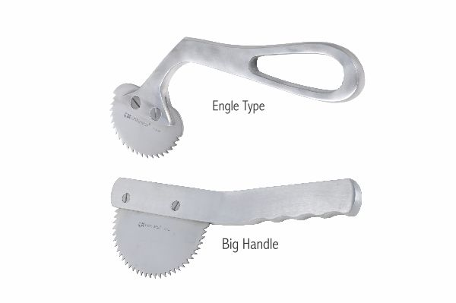
Function
A rigid saw blade with medium-coarse teeth is drawn back and forth across the cast wall in a sawing motion. The coarse tooth geometry cuts through the abrasive plaster material efficiently, while the relatively short blade stroke allows controlled cutting in confined positions around the limb perimeter.
Advantages
Power-Independent Cast Removal: The manual saw requires no electrical power source, providing a reliable fallback for cast removal in field conditions, after-hours emergency cast management, and areas of the hospital where electrical equipment access is restricted.
Controlled Access Cutting: The manual saw's compact size and no power cord allow use in positions and orientations where the electric saw's cord or motor housing would obstruct access, such as when cutting window sections in the dorsal limb surfaces.
FAQ
Q: How is skin injury prevented with a manual plaster saw?
A: Unlike the oscillating electric saw, the manual saw does cut skin — use a protective spatula or tongue depressor pushed between the cast and skin ahead of the blade, and work slowly with short, controlled strokes to monitor blade depth.
Q: What blade count is appropriate for a plaster saw blade?
A: Medium-coarse blades of 8–12 teeth per inch are most effective for plaster; finer blades clog with plaster powder, while coarser blades cut too aggressively for controlled removal work.

ORTHOPAEDIC INSTRUMENTS
Plaster Cutting Instruments
Plaster Scissors with Spring
Intended Use
Plaster scissors with spring are heavy-duty, self-opening scissors used to cut through cast padding, stockinette and soft bandage layers during cast application and removal in veterinary patients. The spring mechanism returns the blades to the open position after each cut, reducing hand fatigue during the repetitive cutting involved in multilayer cast construction. | 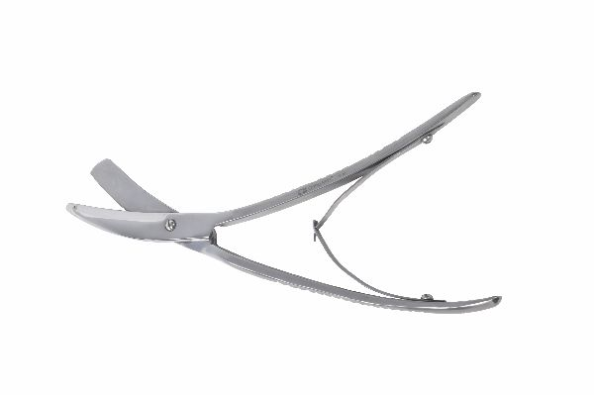
Function
The short, thick blades with angled cutting edges are closed by hand squeeze to cut through the plaster padding or bandage layer. A spring mechanism connected to the handles returns the blades to the open position automatically after each squeeze, eliminating the need to actively open the scissors between cuts and dramatically reducing hand muscle fatigue.
Advantages
Self-Opening Fatigue Reduction: The spring return mechanism eliminates the active finger extension needed to open standard scissors between cuts, reducing extensor muscle fatigue during the hundreds of repetitive cuts needed to apply or remove multi-layered orthopaedic casts in veterinary practice.
Heavy Cast Material Capability: The short, stout blades and strong hinge pivot provide the cutting force needed to shear through multiple layers of cast padding, stockinette, and undercast padding simultaneously, speeding the casting process without requiring separate blade passes through each individual layer.
FAQ
Q: Can plaster scissors be used on fibreglass casting tape?
A: Heavy-duty plaster scissors can cut through the woven fibreglass tape before it hardens, but set fibreglass requires dedicated heavy shears or the electric oscillating saw — standard plaster scissors will not cut hardened fibreglass.
Q: How is the spring mechanism maintained?
A: Clean and dry the spring mechanism thoroughly after each use; moisture trapped in the spring coil causes corrosion that stiffens or breaks the spring, and lubricate with surgical instrument oil before autoclaving.

ORTHOPAEDIC INSTRUMENTS
Plaster Cutting Instruments
Plaster Spreader Hennings
Intended Use
The Hennings plaster spreader is used to open and spread bivalved cast halves or plaster splits during cast removal and cast windowing in veterinary orthopaedics. After longitudinal cuts are made, the spreader levers the cast walls apart to expose the limb without lacerating the skin from sharp cut cast edges. | 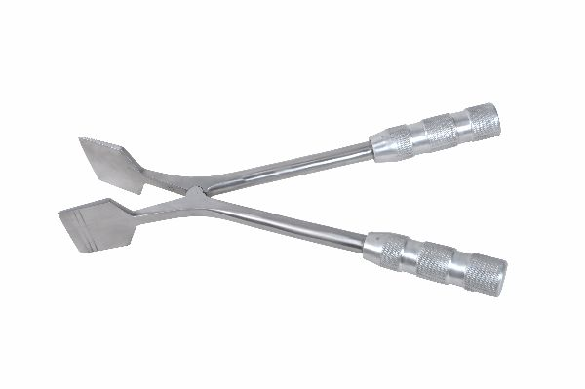
Function
The twin wedge-shaped tips are introduced into the cast cuts and the handles are squeezed together, driving the wedge tips apart and opening the cast walls. Repositioning along the cut length progressively opens the full cast, converting the bivalved cast into two open shells that can be lifted free from the limb.
Advantages
Wedge Amplified Opening Force: The wedge geometry amplifies the hand squeeze force by mechanical advantage, easily opening tight cast cuts where hand traction alone cannot spread the cast walls — particularly useful in thick multilayer fibreglass casts on large breed dogs.
Controlled Progressive Opening: Working the spreader along the cut in small increments opens the cast progressively without the sudden crack-and-split that results from point-loading the cast from a single location, preventing sharp plaster shard formation that causes skin injury.
FAQ
Q: Does the Hennings spreader work on fibreglass casts?
A: Yes — fibreglass is more flexible than plaster and opens readily with the Hennings spreader after bilateral cuts are made with the electric oscillating saw; the rigid fibreglass edges are less likely to shatter than brittle plaster.
Q: Is the plaster bender or Hennings spreader preferred for cast removal?
A: Both instruments perform the same task; the spreader's wedge action may be more effective on tight-fitting casts, while the bender's jaw design is preferred when cast walls need to be bent outward and held open rather than just separated at the cut line.

ORTHOPAEDIC INSTRUMENTS
Plaster Cutting Instruments
S.S. Blade for Electric Plaster Saw
Intended Use
The stainless steel replacement blade for the electric plaster saw is the consumable cutting element of the powered cast removal system. SS blades provide superior corrosion resistance compared to standard carbon steel blades, maintaining cutting sharpness and integrity through repeated steam sterilisation cycles in veterinary practice. | 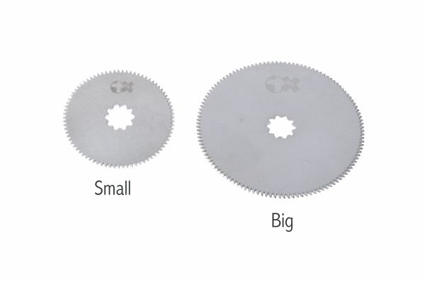
Function
The SS blade oscillates against the cast material, with the serrated teeth cutting through plaster or fibreglass on the oscillating arc. The blade mounting interface attaches securely to the saw's oscillating head and is quickly replaceable when blade sharpness is reduced, restoring full cast-cutting efficiency between patients.
Advantages
Corrosion-Resistant Longevity: Stainless steel construction resists the corrosion that rapidly degrades standard carbon steel blades after repeated sterilisation and exposure to wet plaster, maintaining usable cutting sharpness for more cases per blade and reducing the long-term cost of blade replacement.
Quick-Change Blade System: The quick-change mounting interface allows blade replacement in under 60 seconds without tools, enabling rapid blade change between cases or mid-procedure when a blade becomes dull — maintaining efficient cast removal without time-consuming instrument disassembly.
FAQ
Q: How many casts can one SS blade remove before replacement?
A: Depending on cast thickness and material, a sharp SS blade removes 5–10 standard plaster casts before dulling requires replacement; fibreglass casts wear blades faster due to the harder, more abrasive fibre-composite material.
Q: Are SS blades compatible with all electric plaster saw brands?
A: Blade compatibility is brand-specific; confirm the blade mounting profile matches the specific electric plaster saw in use — incompatible blades either fail to mount securely or create eccentric oscillation that damages both blade and saw motor.

